Mockito Hands-On Exercises
Exercise 1: Mocking and Stubbing
Scenario: You need to test a service that depends on an external API.
Use Mockito to mock the external API and stub its methods.
Steps: 1. Create a mock object for the external API.
2. Stub the methods to return predefined values.
3. Write a test case that uses the mock object.
Solution Code:
import static org.mockito.Mockito.*;
import org.junit.jupiter.api.Test;
import org.mockito.Mockito;
public class MyServiceTest {
@Test public void testExternalApi() {
ExternalApi mockApi = Mockito.mock(ExternalApi.class); when(mockApi.getData()).thenReturn("Mock Data");
MyService service = new MyService(mockApi);
String result = service.fetchData();
assertEquals("Mock Data", result);
} }

SOLUTION:
ExternalApi.java:
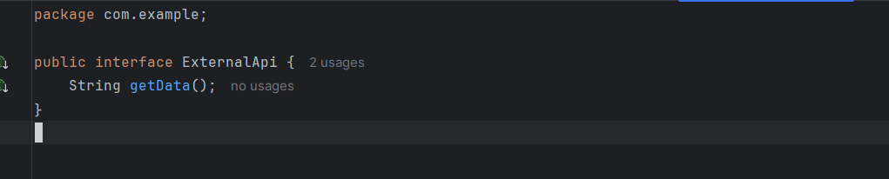

MyService.java:
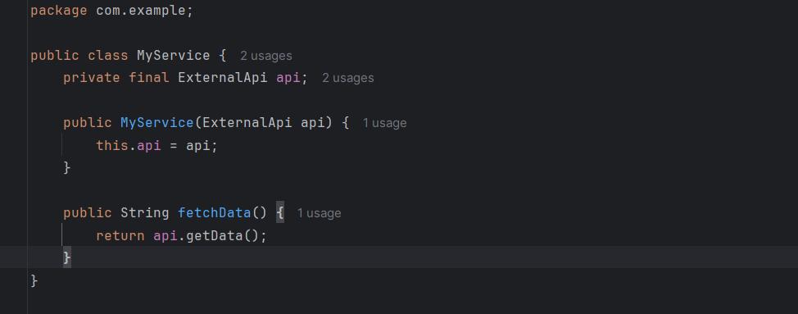
MyServiceTest.java:
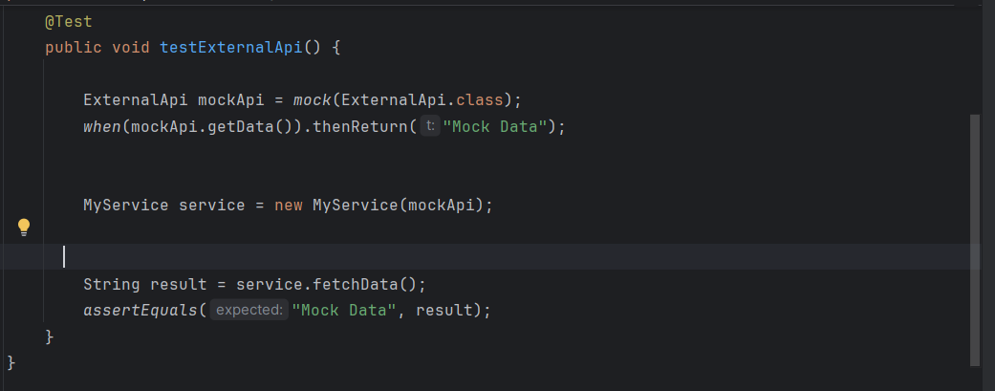
OUTPUT:
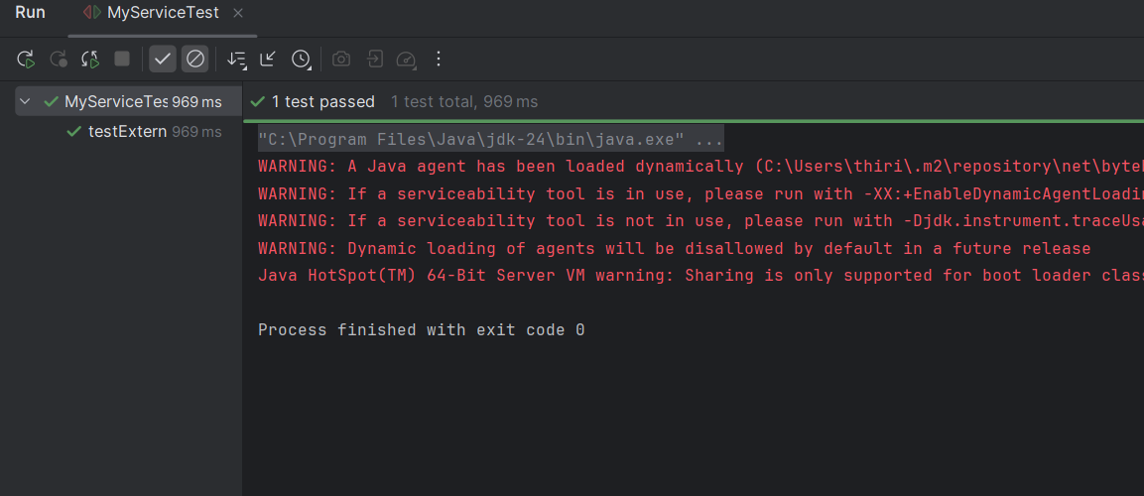

Exercise 2: Verifying Interactions
Scenario: You need to ensure that a method is called with specific arguments.
Steps: 1. Create a mock object.
2. Call the method with specific arguments.
3. Verify the interaction.
Solution Code:
import static org.mockito.Mockito.*;
import org.junit.jupiter.api.Test;
import org.mockito.Mockito;
public class MyServiceTest {
@Test public void testVerifyInteraction() {
ExternalApi mockApi = Mockito.mock(ExternalApi.class);
MyService service = new MyService(mockApi);
service.fetchData();
verify(mockApi).getData();
} }

SOLUTION:
ExternalApi.java:
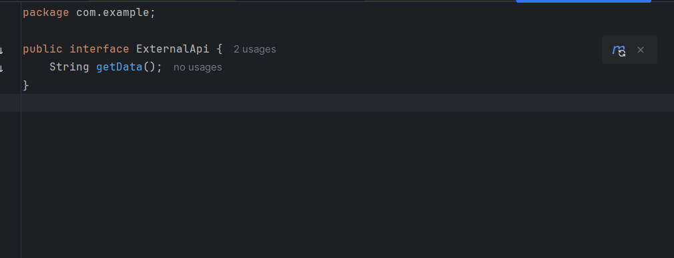
MyService.java:
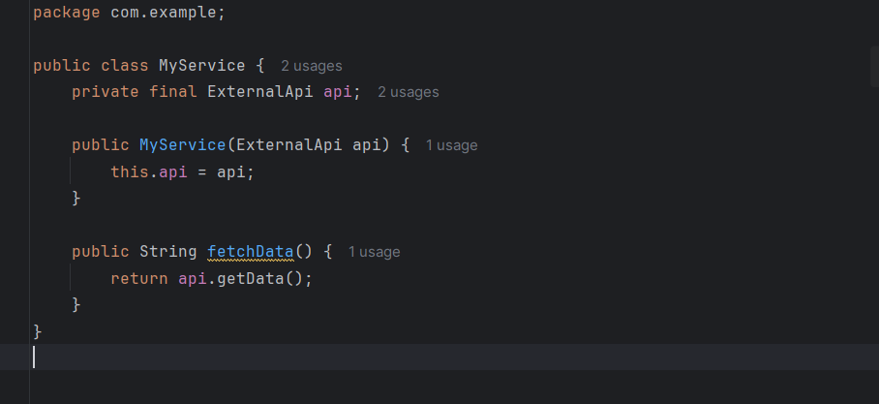
MyServiceTest.java:
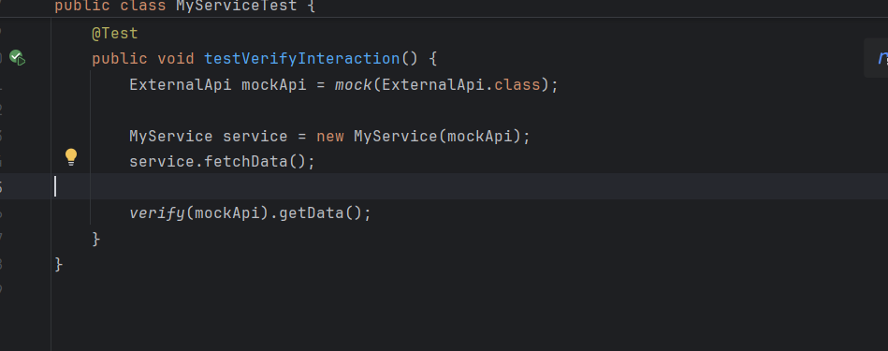
OUTPUT:
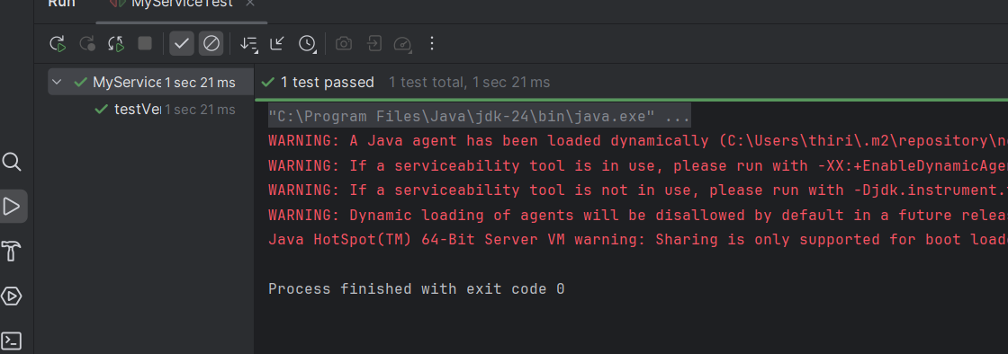

Exercise 3: Argument Matching
Scenario: You need to verify that a method is called with specific arguments.
Steps: 1. Create a mock object.
2. Call the method with specific arguments.
3. Use argument matchers to verify the interaction.
SOLUTION:
EmailService.java:
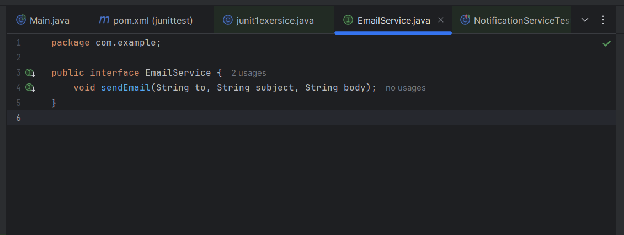
NotificationService.java:
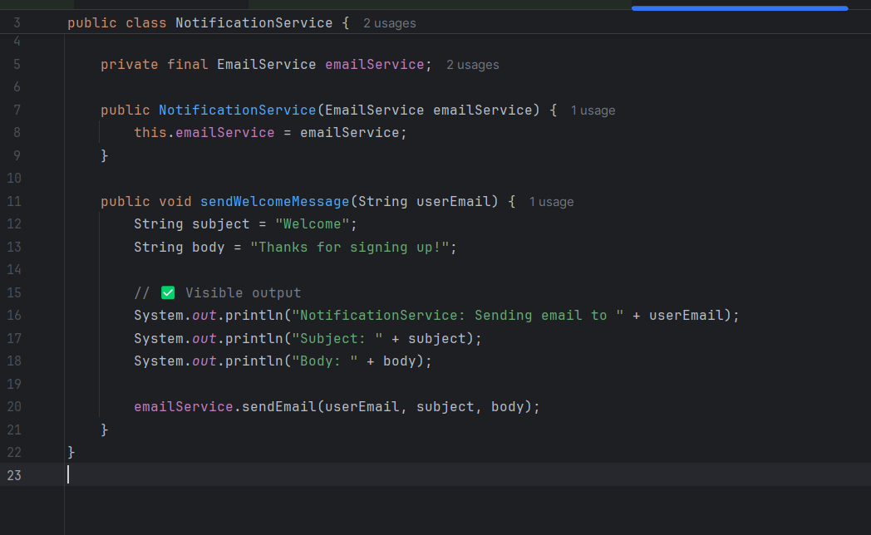
AllTest.java:
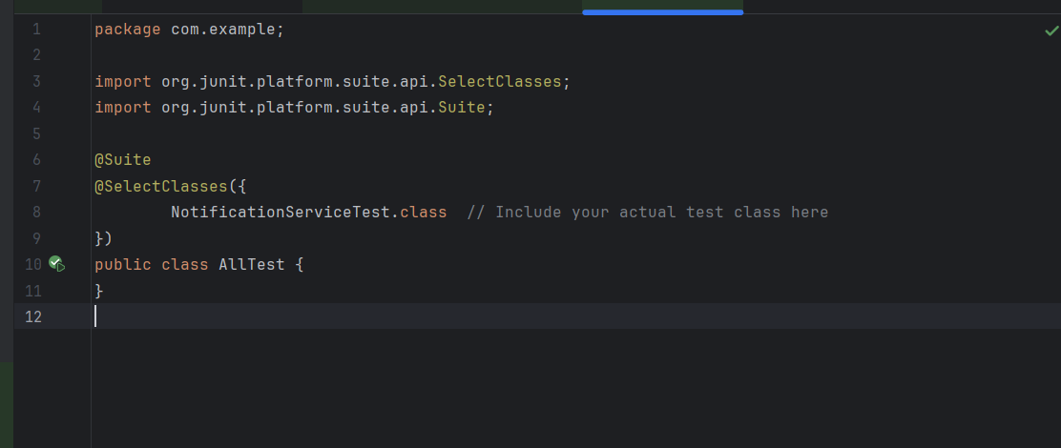
NotificationServiceTest.java:
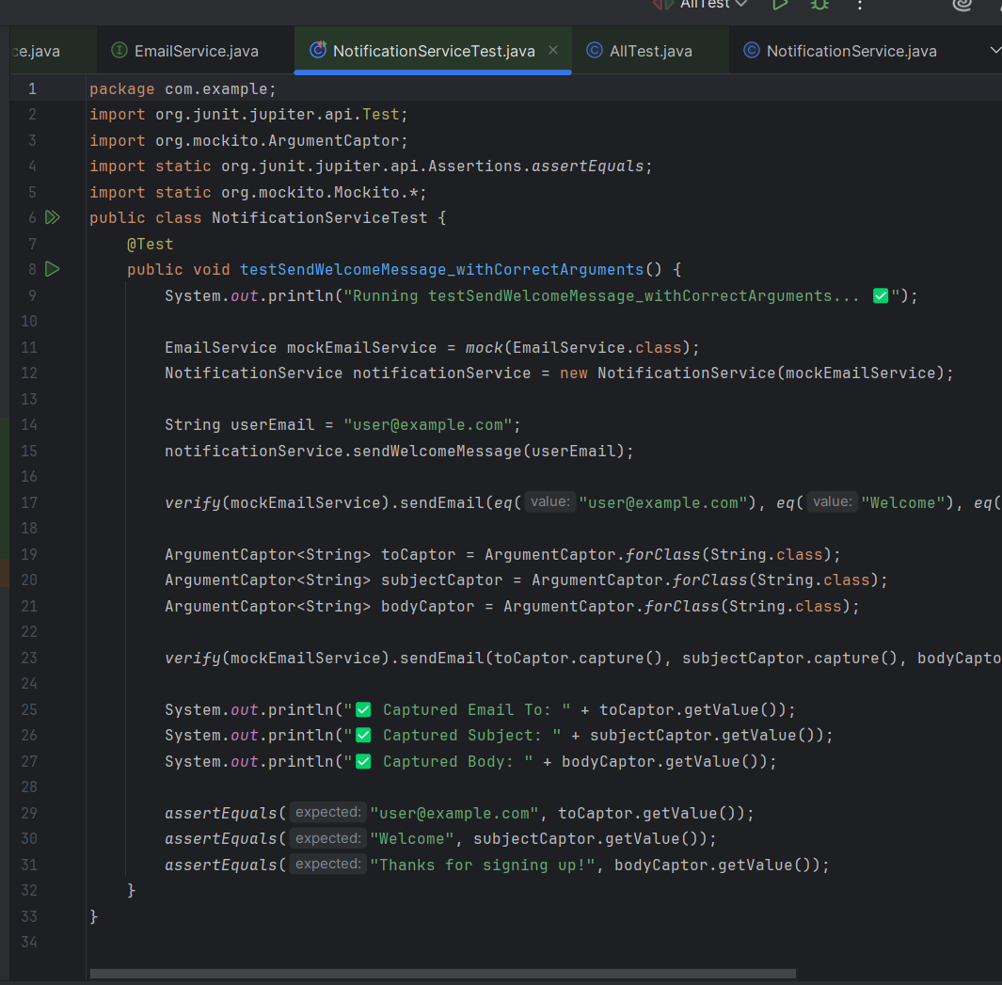

OUTPUT:
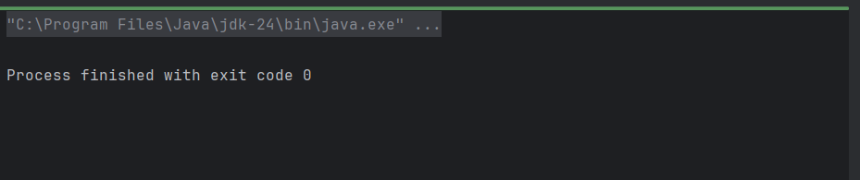
Exercise 4: Handling Void Methods
Scenario: You need to test a void method that performs some action.
Steps: 1. Create a mock object.
2. Stub the void method.
3. Verify the interaction.
SOLUTION:
LoggerService.java:
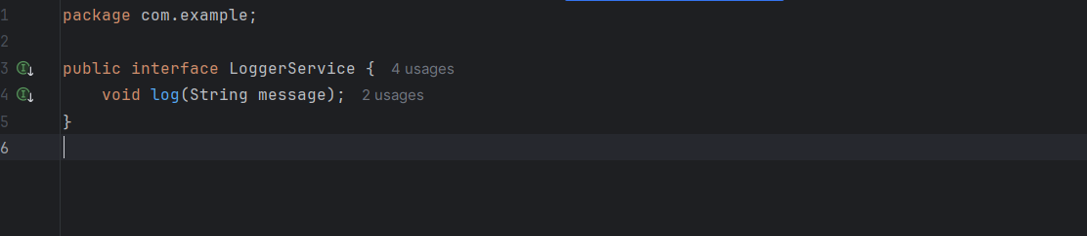
UserService.java: 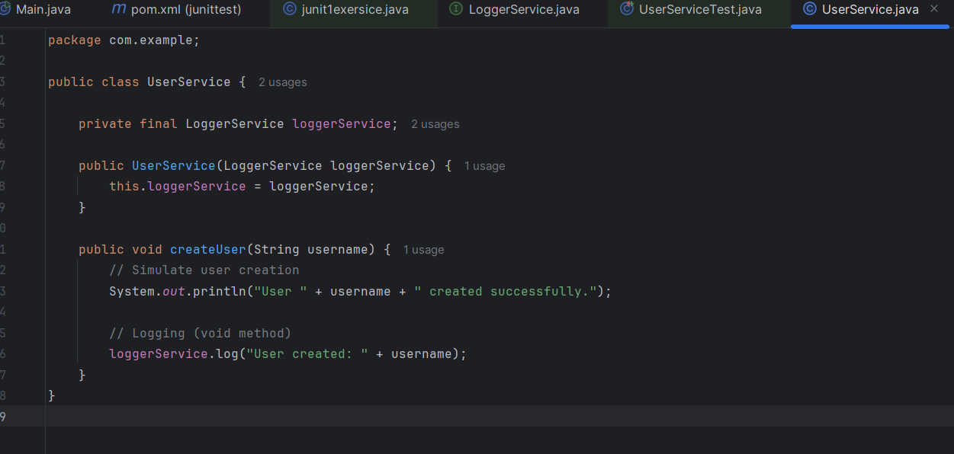

UerServiceTest.java:
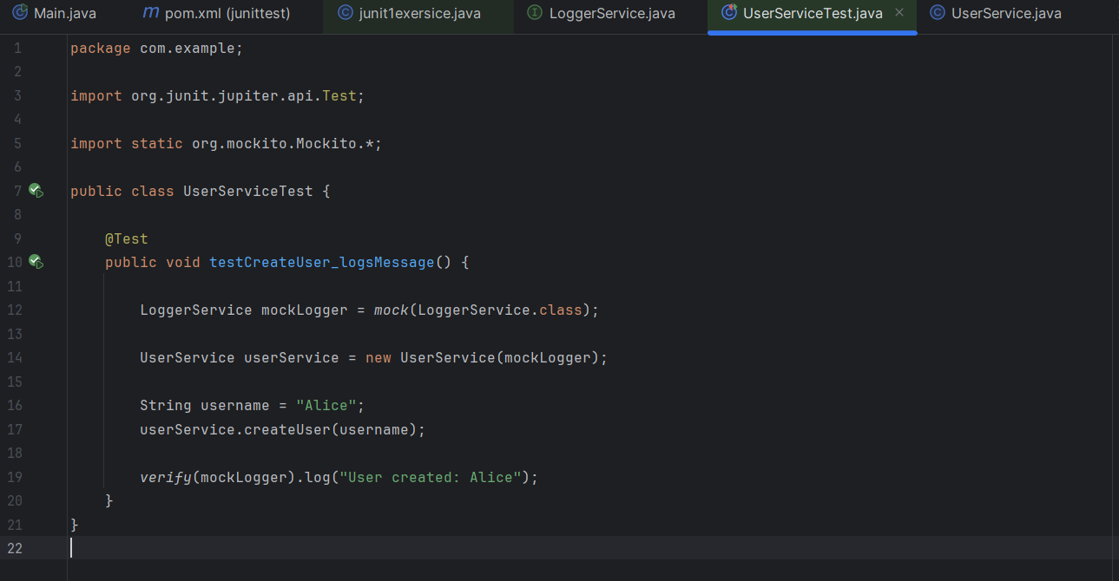

SOLUTION:

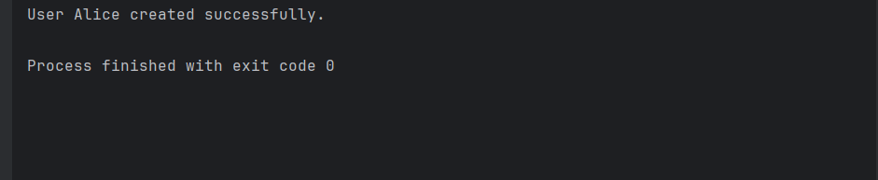

Exercise 5: Mocking and Stubbing with Multiple Returns
Scenario: You need to test a service that depends on an external API with multiple return values.
Steps: 1. Create a mock object for the external API.
2. Stub the methods to return different values on consecutive calls.
3. Write a test case that uses the mock object.
SOLUTION:
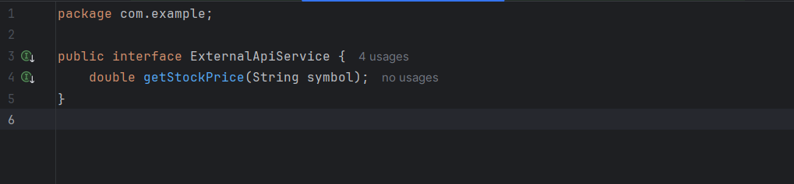
StockMonitorService.java:
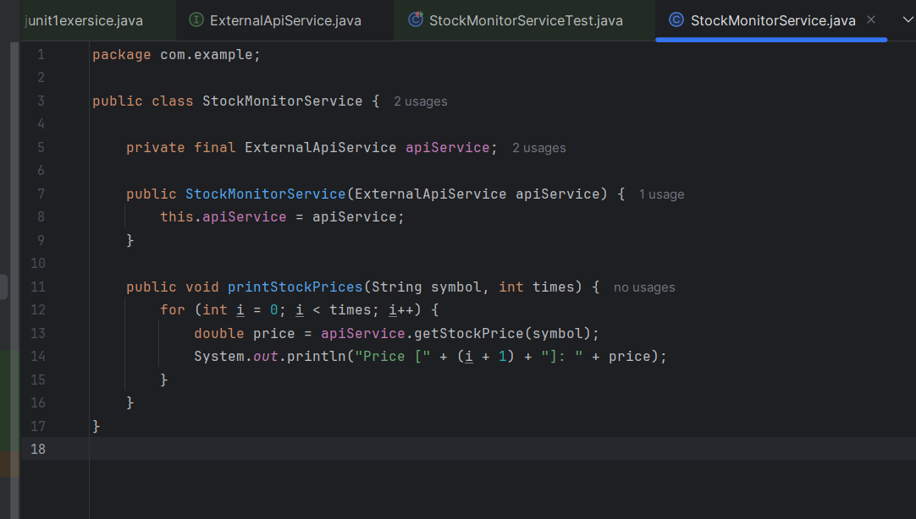
StockMonitorServiceTest.java:
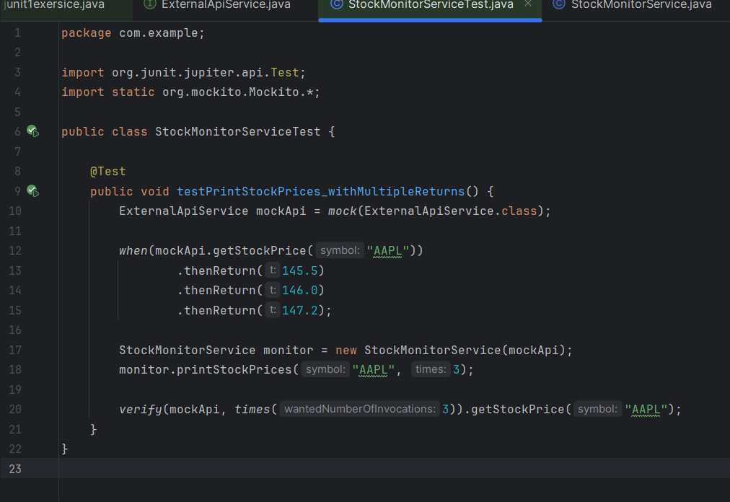

OUTPUT:

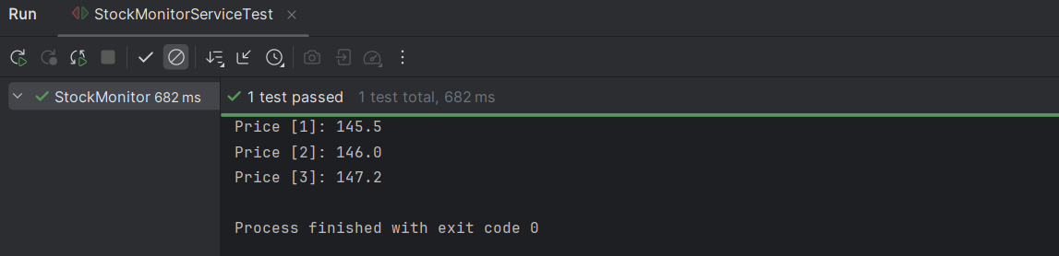

Exercise 6: Verifying Interaction Order
Scenario: You need to ensure that methods are called in a specific order.
Steps: 1. Create a mock object.
2. Call the methods in a specific order.
3. Verify the interaction order.
SOLUTION:
NetworkClient.java:
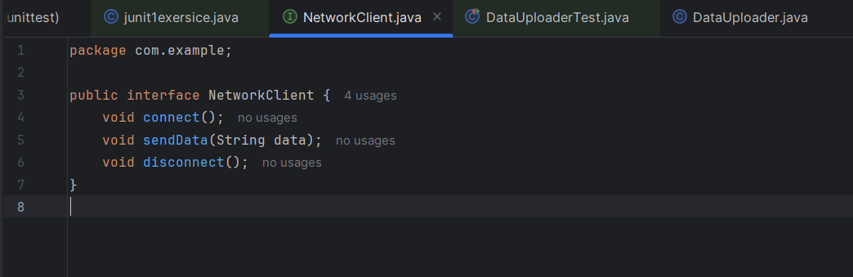
DataUploader.java:
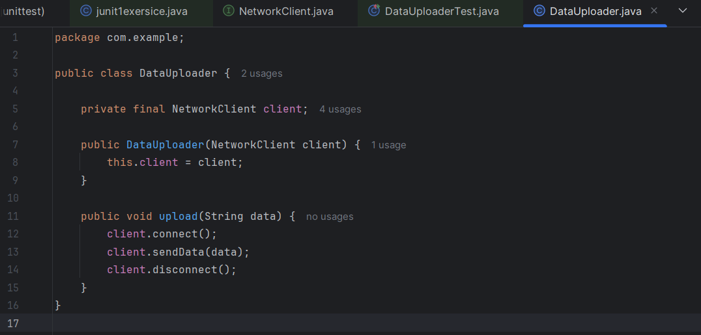

DataUploaderTest.java:
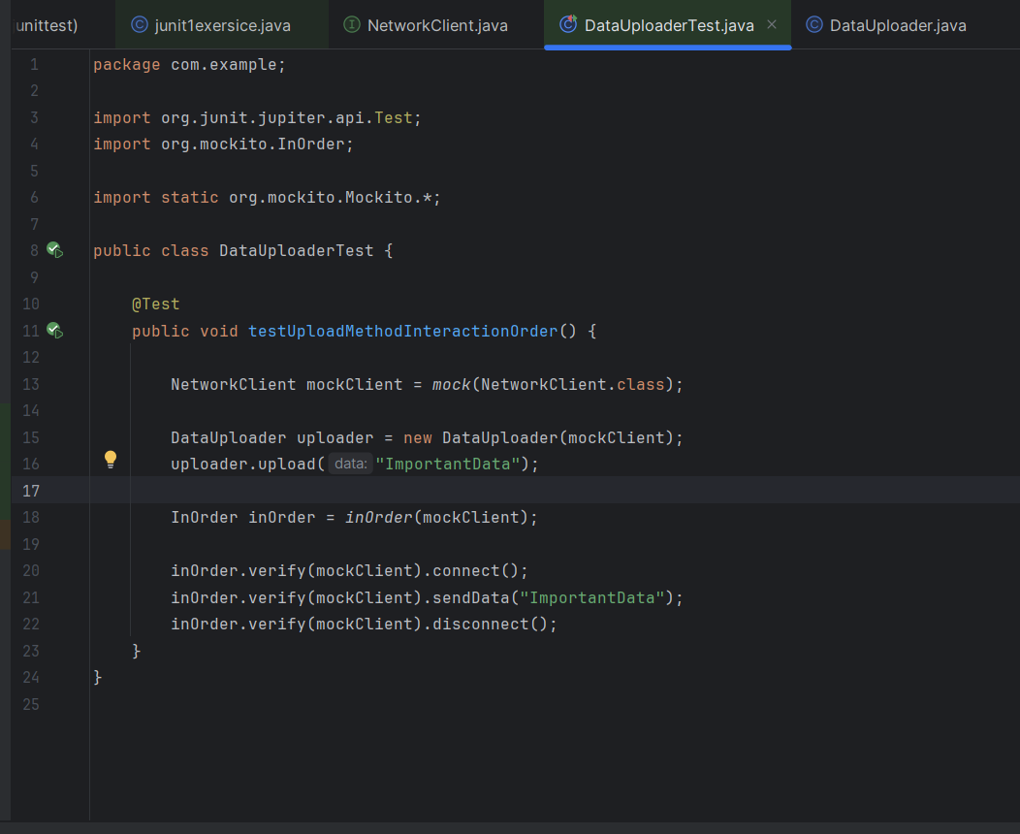

OUTPUT:

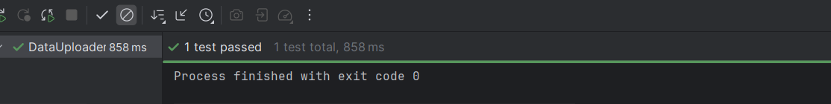

Exercise 7: Handling Void Methods with Exceptions
Scenario: You need to test a void method that throws an exception.
Steps: 1. Create a mock object.
2. Stub the void method to throw an exception.
3. Verify the interaction.
SOLUTION:
FileService.java:
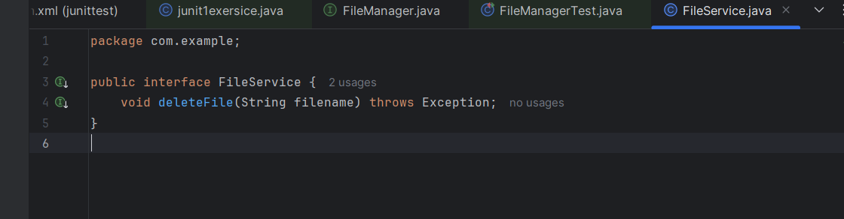

FileManager.java:
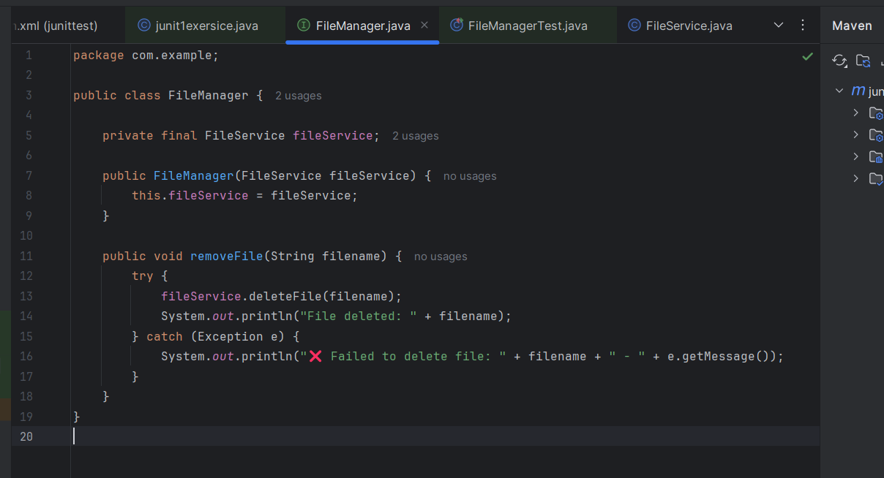
FileManagerTest.java:
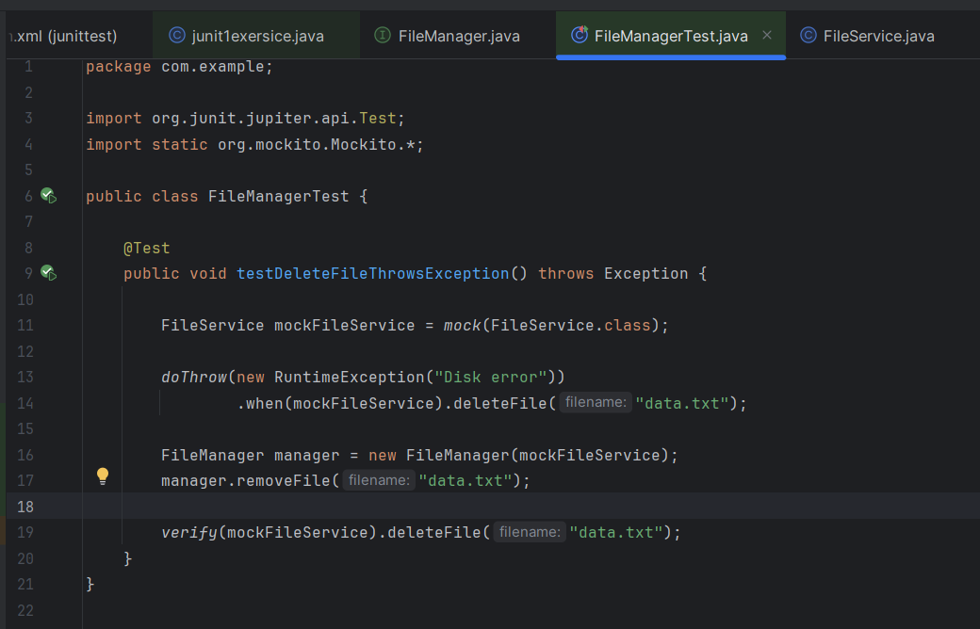

OUTPUT:
